
Company
Logotype

Cone Beam Computed Tomography- Report



Porur Dental X-rays & CBCT

Patient Name : Mrs. Sangamithra | Date of Report : 13.05.2024
Age/ Gender : 44 years/ Female | Region of Interest : CBCT Mandible
Referring doctor: 32 Dental | Indication : Impacted tooth 48
Clinical Notes: Nil
PATIENT INFORMATION

CBCT- Mandible provided
CBCT – IMAGE DETAILS

RADIOGRAPHIC INTERPRETATION

- No of teeth present in the right side of mandibular arch : 16
- The long axis of 38 appears to be parallel to the long axis of the adjacent 37 tooth with its occlusal plane adjacent to the middle third of the root of 37. However, the radicular portion of 38 is present with a sharp distal curvature of the apical third.
- The distal aspect of 38 is present with single, diffuse, expansile, multilocular, hypodense area bounded by a corticated margin measuring 31.88 mm mesio-distally x 14.11 mm bucco-lingually. The height of the hypodense region in the present image is 27.18 mm and appears to extend superiorly (superior limitation of the lesion not visible in the provided FOV).
- The hypodense lesion appears to push the inferior alveolar canal inferiorly and lingually. It also appears to cause extreme thinning of the lingual and buccal cortical bone.
- Distance between the root of 38 and the Inferior Alveolar Nerve canal: close proximity (0.8 mm)
- Distance between lesion and the Inferior Alveolar Nerve canal: in contact

RADIOGRAPHIC IMPRESSION

- Impacted tooth: 38.
- Differential Diagnosis (based on the visible radiological features): Benign Odontogenic cyst/ tumor in relation to the left mandibular ramus, and left mandibular body region.

Kindly correlate with clinical findings


IMAGES FOR REFERENCE

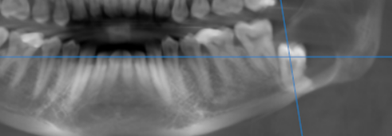
3-DIMENSIONAL VIEW
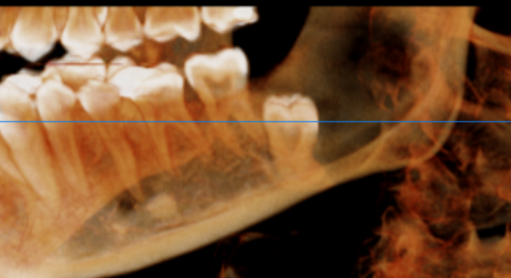

CROSS SECTIONAL VIEW

38 region- and its relation to inferior alveolar nerve canal | 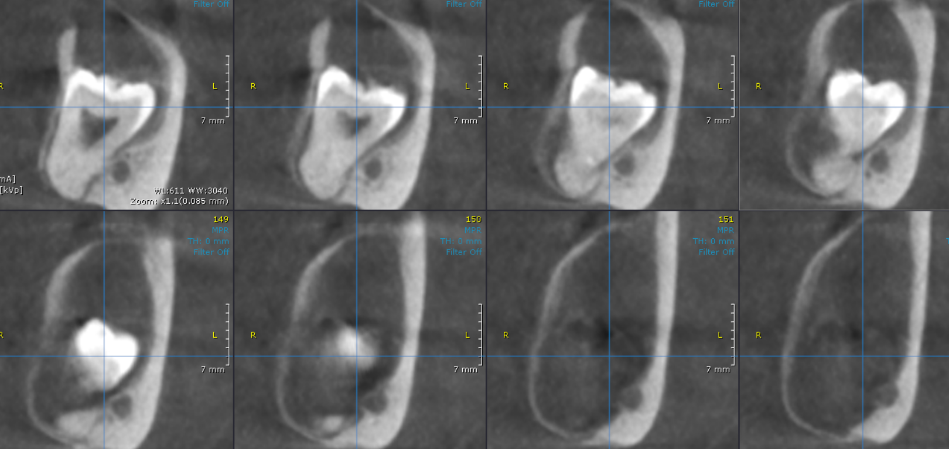

**** End of report ****

